**NBA Awards**

We will look at the 4 most popular yearly awards – MVP, defensive player of the year, most improved player as well as the 6th man of the year award and try finding correlations from given metrics. The main issue here is that after beginning the project, I discovered that the awards are given by a panel of 124 sportswriters and broadcasters throughout the United States and Canada, naturally there may (and typically is) a certain element of bias. We will also look at the top 4 teams for each year and find out if any metrics were more prevalent than others.

Another factor to consider, is that the stats below are for the regular season. NBA stats in the playoffs also have to be considered to get a full picture. These will be looked at in another analysis

The metrics provided are:

* MP – Minutes player
* FT – Free throws
* TRP - Total Rebound Percentage. Total rebound percentage is an estimate of the percentage of available rebounds a player grabbed while he was on the floor.
* AST – Assists
* STL – Steals
* BLK – Block
* TOV – Turnover
* PF – Personal Fouls
* PTS – Points

We will first look at the top 3 teams from each conference, from the west we have the Golden State Warriors, San Antonio Spurs and the Houston Rockets. The east conference top 3 teams were the Boston Celtics, Cleveland Cavaliers and the Toronto Raptors

2017 Winners –Golden State Warriors.

Having lost to the Cavaliers in the final the previous year, the GSW acquired Kevin Durant for the 2017. Let’s look at the team stats for the regular season.

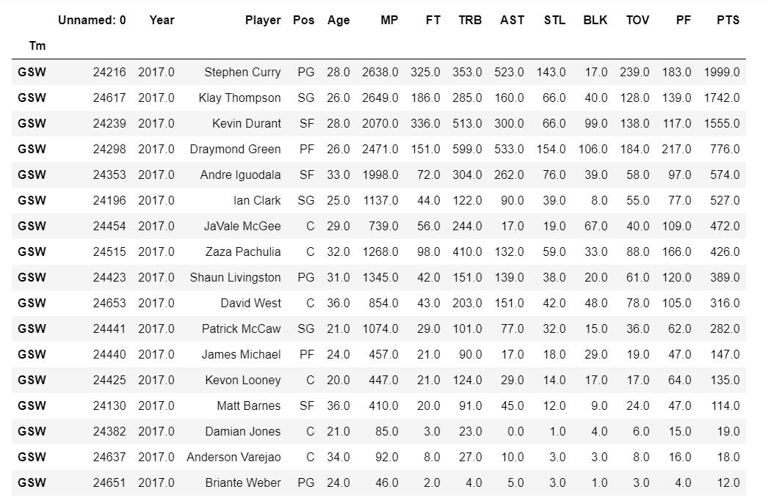

San Antonio Spurs

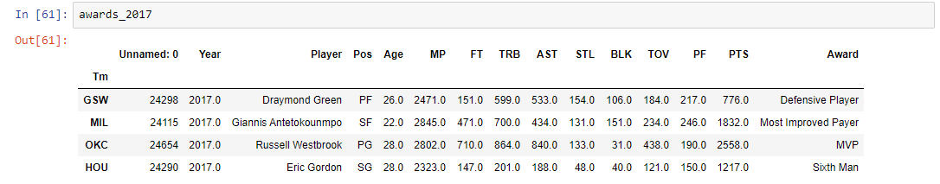

Defensive player of the year – Draymond Green

Defensive stats are TRB, STL & BLK. This is a gross oversimplification – boarder incorrect, as we are ignoring many other factors that are either not provided, or not representable on paper. For example the positive effect a player has on the team. As we will see, Draymond is typically not known to have the best stats in terms of defensive effectiveness, however he was known to be the glue of the season winning team.

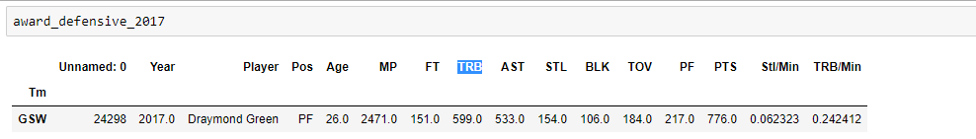

Total rebounds leaders 2017

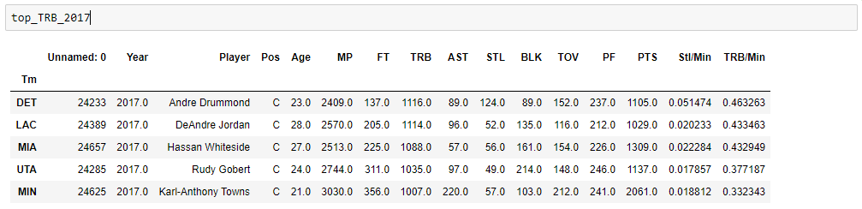

Total steals and total steals per minute for the league leaders in steals

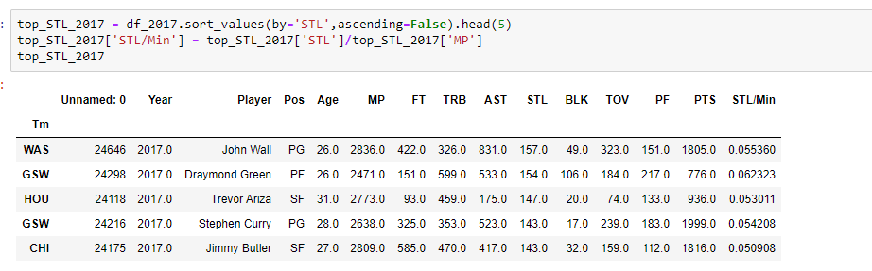

Total Blocks with blocks per minute.

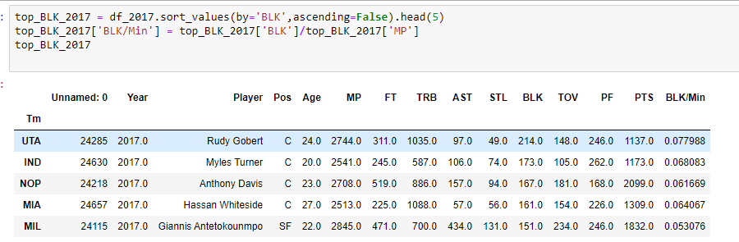

Most Valuable Player – Russel Westbrook

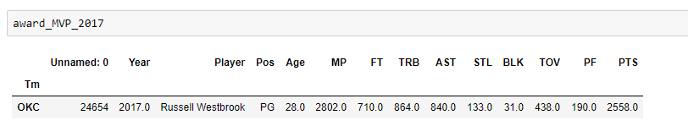

As MVP we will actually be looking at every metric provided. As most valuable player, both defensive and offensive stats. One also has to consider that Russell Westbrook also completed a near impossible task of having a double-double for the year. The double-double is double digits in PTS and STL/BLK.

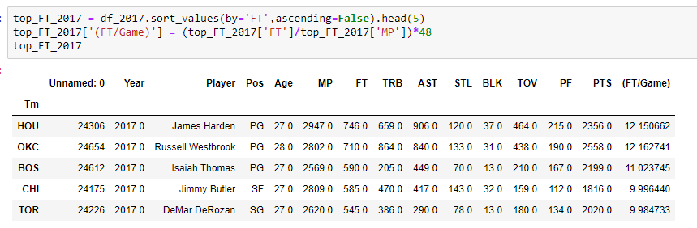

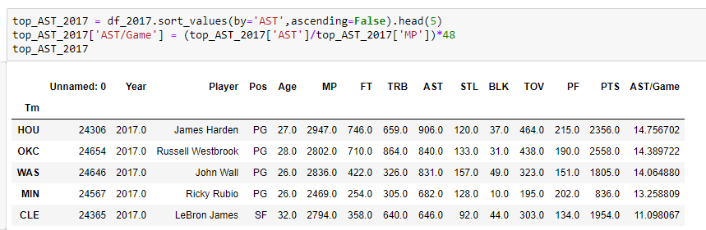

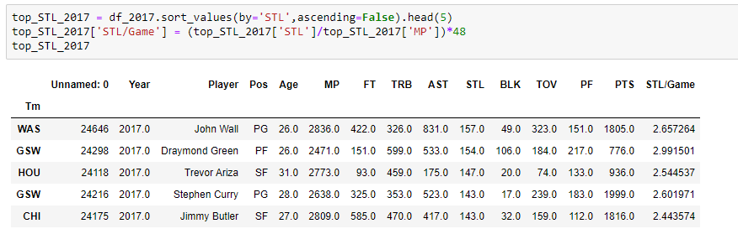

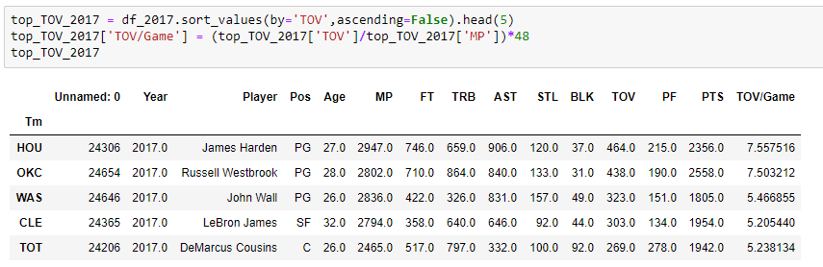

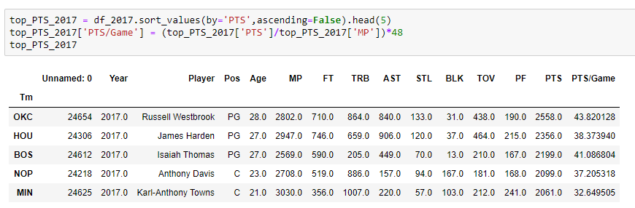

To evaluate the most improved player, we will need to look at the stats of previous years. The runners up for the award were Rudy Gobert and Nikola Jokic.

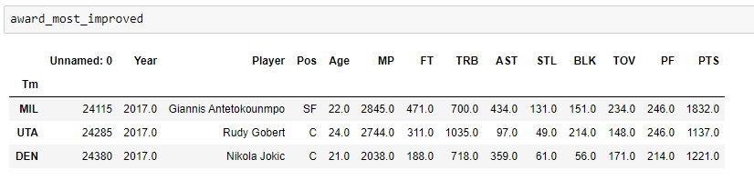

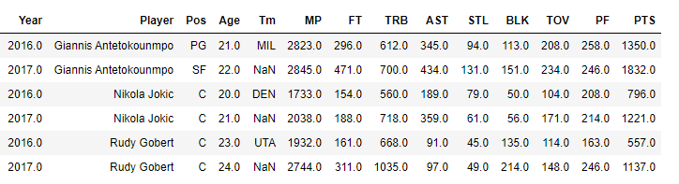

2016

